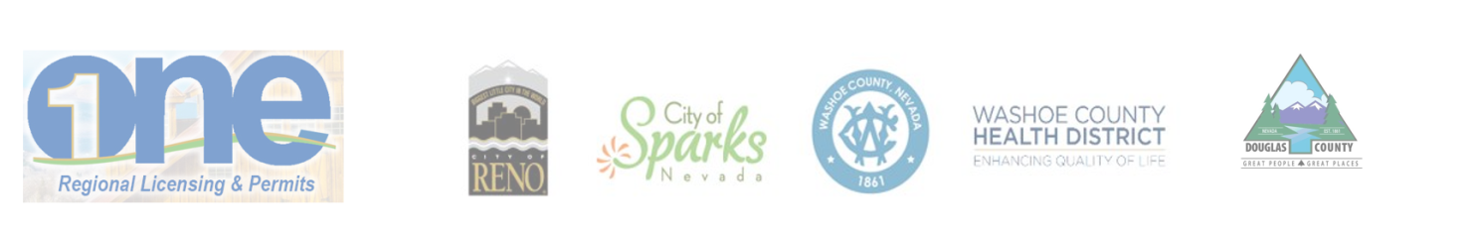Regional Business License and Permits Program

AGENDA

Regional Business License and Permits Program Oversight Group

Quarterly Meeting
September 4, 2018

Oversight Group
Reno City Manager – Sabra Newby
Sparks City Manager – Steve Driscoll
Washoe County Manager – John Slaughter
District Health Officer – Kevin Dick
Douglas County Community Development Director – Mimi Moss

The September 4, 2018, meeting of
the Oversight Group has been cancelled.

Public Notice: This agenda has been physically posted in compliance with NRS 241.020(3) (notice of meetings) at Reno City Hall, One East 1st Street, Reno, NV; Washoe County Administrative Office, 1001 E. Ninth Street, Reno, NV; Sparks City Hall, 431 Prater Way, Sparks, NV; Washoe County Health District, 1001 E. Ninth Street, Reno, NV; Washoe County Downtown Reno Library, 301 South Center Street, Reno, NV; Evelyn Mount Northeast Community Center, 1301 Valley Road, Reno, NV; McKinley Arts and Culture Center, 925 Riverside Drive, Reno, NV; Reno Municipal Court, One South Sierra Street, Reno, NV; and Reno-Sparks Convention and Visitors Authority, 4001 South Virginia Street, Suite G, Reno, NV. Douglas County Administration Building 1616 8th Street, Minden, NV; Douglas County Public Library, Minden, NV; Minden Inn Administration Building, 1594 Esmeralda, Minden, NV; US Post Office-Minden, 1640 U.S. Hwy. 395, Minden, NV; Judicial & Law Enforcement Center, 1038 Buckeye Rd., Minden, NV. In addition, this agenda has been electronically posted in compliance with NRS 241.020(3) at the following websites: www.washoecounty.us/technology; www.reno.gov; www.cityofsparks.us, www.douglascountynv.gov and https://notice.nv.gov/ per NRS 232.2175.

